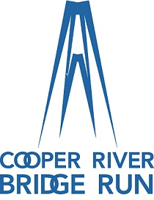

2021 VOLUNTEER!
To be a part of the best race in the Southeast!

Fill out this form, check the type of work preferred and we will try to accommodate you, OR sign up
online at www.bridgerun.com/volunteer. Our volunteer coordinator will contact you!
For additional questions please contact the volunteer coordinator, Benita Shaw at (843) 693-9689 or
E-mail Benitasc@yahoo.com Mail form to: Cooper River Bridge Run / PO Box 22089, Charleston, SC, 29413

Please check Volunteer choices below:
PRE-RACE / Expo / September 23&24, 2021
O Thursday, September 23, 11:30 AM – 3:00 PM
O Thursday, September 23, 2:30 PM – 5:30 PM
O Thursday, September 23, 5:00 PM – 8:00 PM
O Friday, September 24, 7:30 AM – 10:30 PM
O Friday, September 24, 10:00 AM – 1:00PM
O Friday, September 24, 12:30 PM – 3:30 PM
O Friday, September 24, 3:00 PM – 6:00 PM
O Friday September 24, 5:30 PM – 8:30 PM

RACE DAY/ September 25, 2021

O Finish Festival, Marion Square - 7:00 AM – Noon
(Corner of King and Calhoun)

GROUP NAME _________________________ Contact person _______________________
# of participants ___________ Please list names on back of sheet
Assignment choice__________________________________
Name: __________________________________ Age: ________ Email: ______________________

Phone: (day) _____________________________ (cell) ___________________________________

Club/Organization Affiliation (if any): _________________________________________________

